**CHAPTER 5  DDL/DML COMMANDS**

**Data Definition Language(DDL) Queries:**

**Category table:**

CREATE TABLE Category (

category_id INT(11) NOT NULL AUTO_INCREMENT,

category_title VARCHAR(255) NOT NULL,

PRIMARY KEY (category_id)

);

**Product table:**

CREATE TABLE Product (

product_id INT(11) NOT NULL AUTO_INCREMENT,

category_id INT(11) NOT NULL,

product_title VARCHAR(255) NOT NULL,

product_desc TEXT NOT NULL,

product_key VARCHAR(255) NOT NULL,

product_img VARCHAR(255) NOT NULL,

product_price DECIMAL(10,2) NOT NULL,

date DATE NOT NULL,

PRIMARY KEY (product_id),

FOREIGN KEY (category_id) REFERENCES Category(category_id)

);

**Cart_Details table:**

CREATE TABLE Cart_Details (

product_id INT(11) NOT NULL,

quantity INT(11) NOT NULL,

PRIMARY KEY (product_id),

FOREIGN KEY (product_id) REFERENCES Product(product_id)

);

**User table:**

CREATE TABLE User (

user_id INT(11) NOT NULL AUTO_INCREMENT,

username VARCHAR(255) NOT NULL,

user_email VARCHAR(255) NOT NULL,

user_password VARCHAR(255) NOT NULL,

user_address TEXT NOT NULL,

user_mobile VARCHAR(20) NOT NULL,

PRIMARY KEY (user_id)

);

**Order_Details table:**

CREATE TABLE Order_Details (

order_id INT(11) NOT NULL AUTO_INCREMENT,

user_id INT(11) NOT NULL,

amount DECIMAL(10,2) NOT NULL,

invoice VARCHAR(255) NOT NULL,

total_products INT(11) NOT NULL,

order_date DATE NOT NULL,

PRIMARY KEY (order_id),

FOREIGN KEY (user_id) REFERENCES User(user_id)

);

**Data Manipulation Language (DML) Queries:**

**1.Home Page**

**Query used to show all category in the side bar:**

• $select_query = "SELECT * FROM `product` ";

**Query used to show all category in the side bar**:

• "Select * from `category` ";

**Query used to filter through catogories:**

• "SELECT * FROM `product` where category_id=$category_id";

**Query used to see price of items in nav bar:**

• $cart_query = "SELECT * FROM cart_details";

• $select_products = "SELECT * FROM product WHERE product_id='$product_id'"

**Query used to insert items into cart:**

• $insert_query="insert into `cart_details` (product_id,quantity) values ($get_product_id,0)";

**Query used to check wether item exists in cart items into cart:**

• $select_query = "SELECT * FROM `cart_details` WHERE product_id=$get_product_id";

**2.Cart**

Query used to display items into cart:

* $select_products = "SELECT * FROM product WHERE product_id='$product_id'";

Query used to update product quantity from the cart:

• $update_cart_qty = "UPDATE `cart_details` SET quantity='$quantities' ";

Query used to delete products from the cart:

• $delete_query = "DELETE FROM `cart_details` WHERE product_id=$remove_id";

**3.Payment**

**Query used to see which user is making the payment:**

• $get_user="Select * from `user_table` ";

**Block of Querys used to get total amount of products in the cart:**

$total_price = 0;

$cart_query_price = **"SELECT * FROM `cart_details`";**

$result_cart_price = mysqli_query($conn, $cart_query_price);

$invoice_number = mt_rand();

$count_products = mysqli_num_rows($result_cart_price);

while ($row_price = mysqli_fetch_array($result_cart_price)) {

$product_id = $row_price['product_id'];

$select_product = **"SELECT * FROM `product` WHERE product_id=$product_id";**

$run_price = mysqli_query($conn, $select_product);

while ($row_product_price = mysqli_fetch_array($run_price)) {

$product_price = array($row_product_price['product_price']);

$product_values = array_sum($product_price);

$total_price += $product_values;

**4.Orders:**

**Query used to insert cart order in the order table:**

* $insert_orders = "INSERT INTO `orders` (user_id, amount, invoice, total_products, order_date) VALUES ($user_id, $subtotal, '$invoice_number', $count_products, NOW())";

**Query used to show a user’s orders in the order table**:

* $get_order_details="SELECT * FROM `orders` WHERE user_id=$user_id"

**5.User Login and Registration:**

**Query Used to Register a new user:**

$insert_query = "INSERT INTO user_table (username, user_email, user_password, user_address, user_mobile)VALUES ('$username', '$user_email', '$user_password', '$user_address', '$user_mobile')";

**Query Used to check if a user already exists while registering a new user:**

$select_query = "SELECT * FROM `user_table` WHERE username='$username'";

**Query Used to read username while logging in a user:**

$select_query="Select * from `user_table` where username= '$user_username '";

**6.Admin Operations**

**Query Used to insert a new category:**

$insert_query="insert into `category` (category_title) values ('$category_title')";

**Query Used to check if a user already exists while registering a new user:**

* $select_query="Select * from `category` where category_title= '$category_title'";

**Query used to show which categories are available while inserting a new product:**

* $select_query="SELECT * FROM `category`";

**Query Used to insert a new product:**

* $insert_products="INSERT INTO `product` (product_title, product_desc, product_key, category_id, product_img, product_price, date, status)

VALUES('$product_title', '$product_desc', '$product_keyword', '$product_categories', '$product_img', '$product_price', NOW(), '$status')"; $result_query=mysqli_query($conn,$insert_products);

**Query Used to all users:**

* $get_users = "SELECT * FROM `user_table`";

**Query Used to show all orders:**

* $get_orders="Select * from `orders`";

**Query Used to show all products:**

* $get_products = "SELECT * FROM `product`";

**CHAPTER 6: RESULTS & SNAPSHOTS**

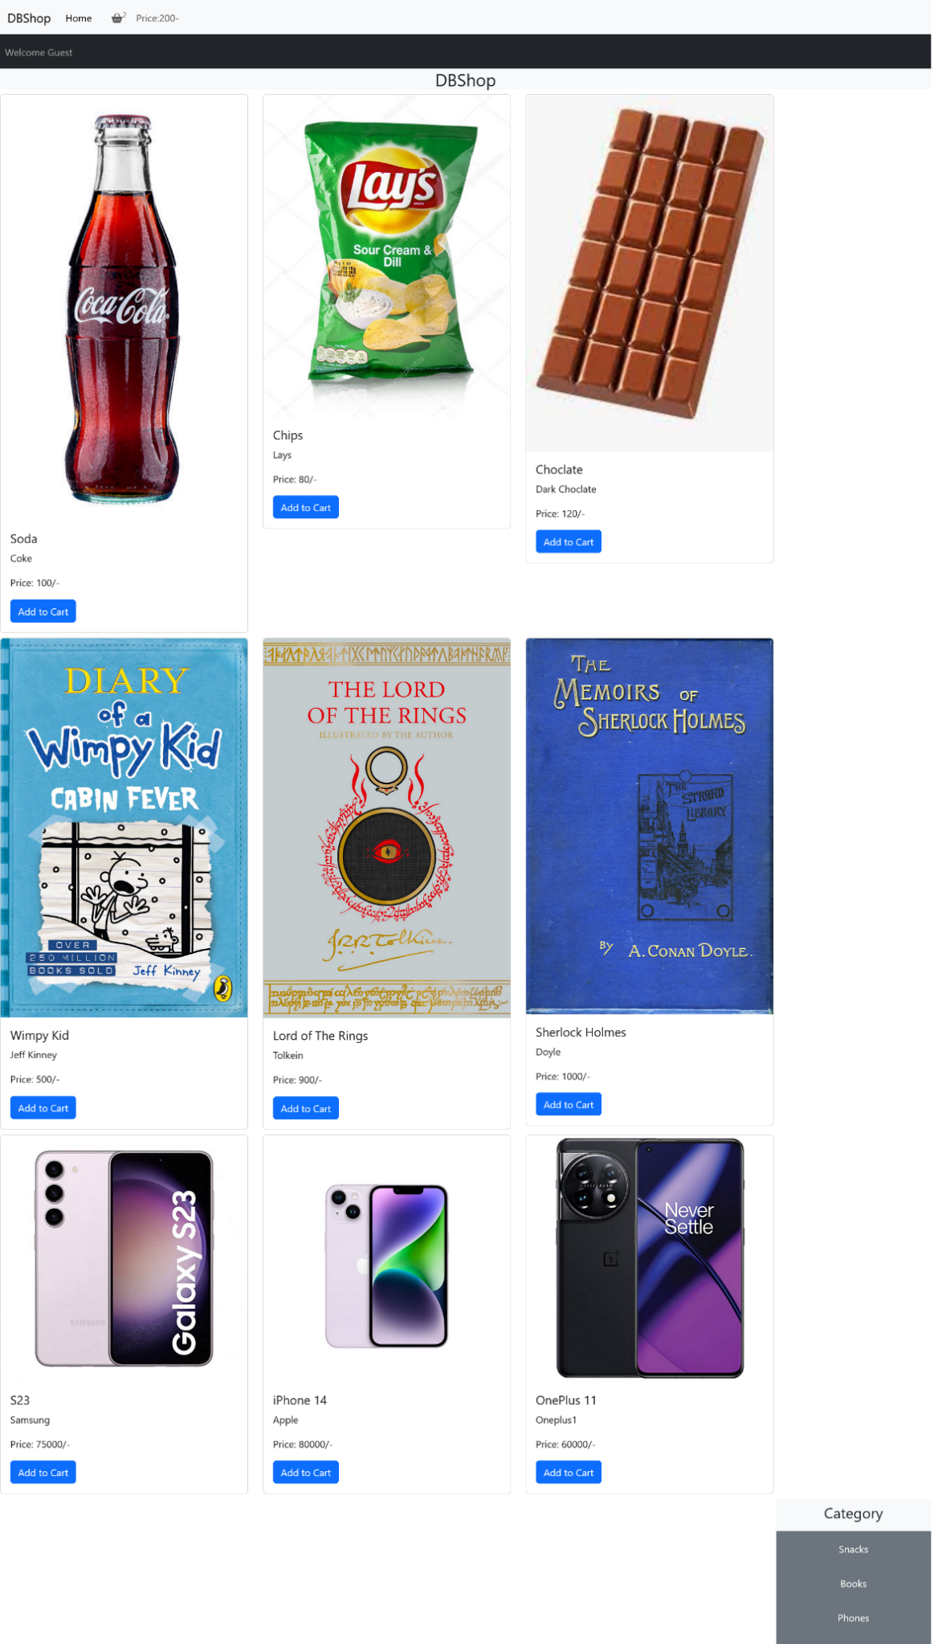**HomePage:**

**Cart Page:**

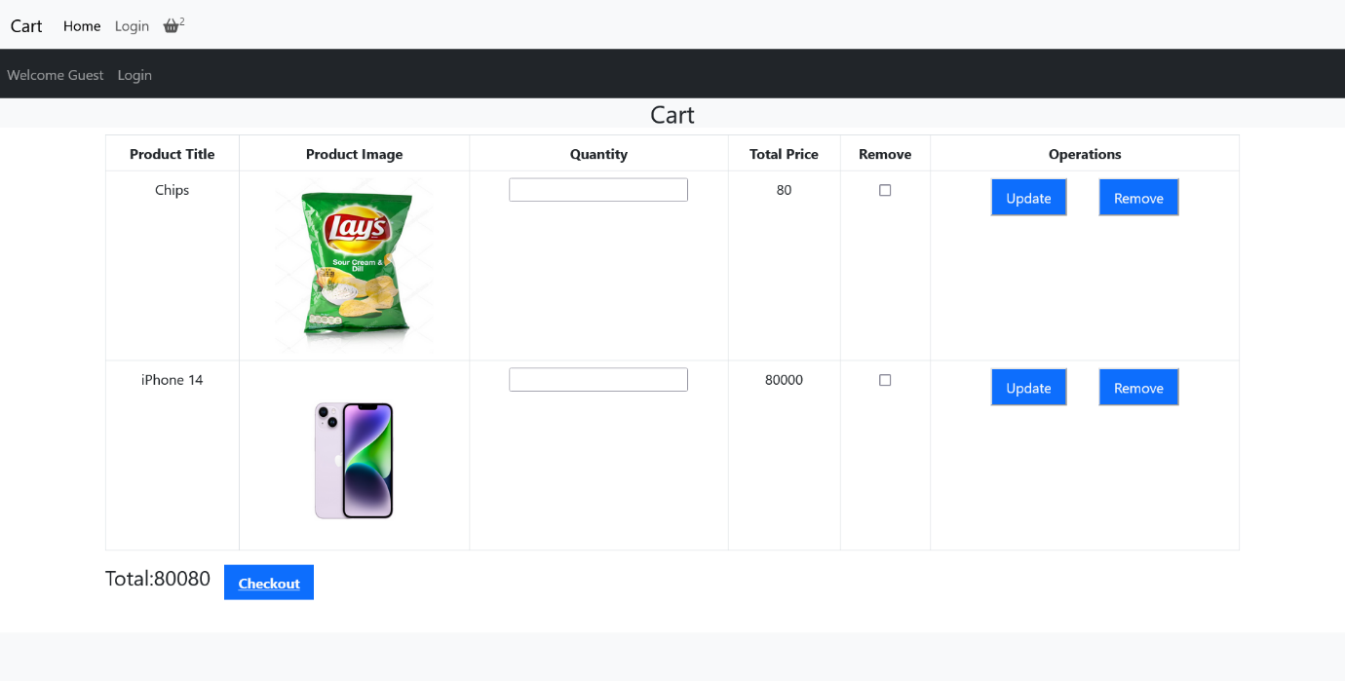

**Login Page:**

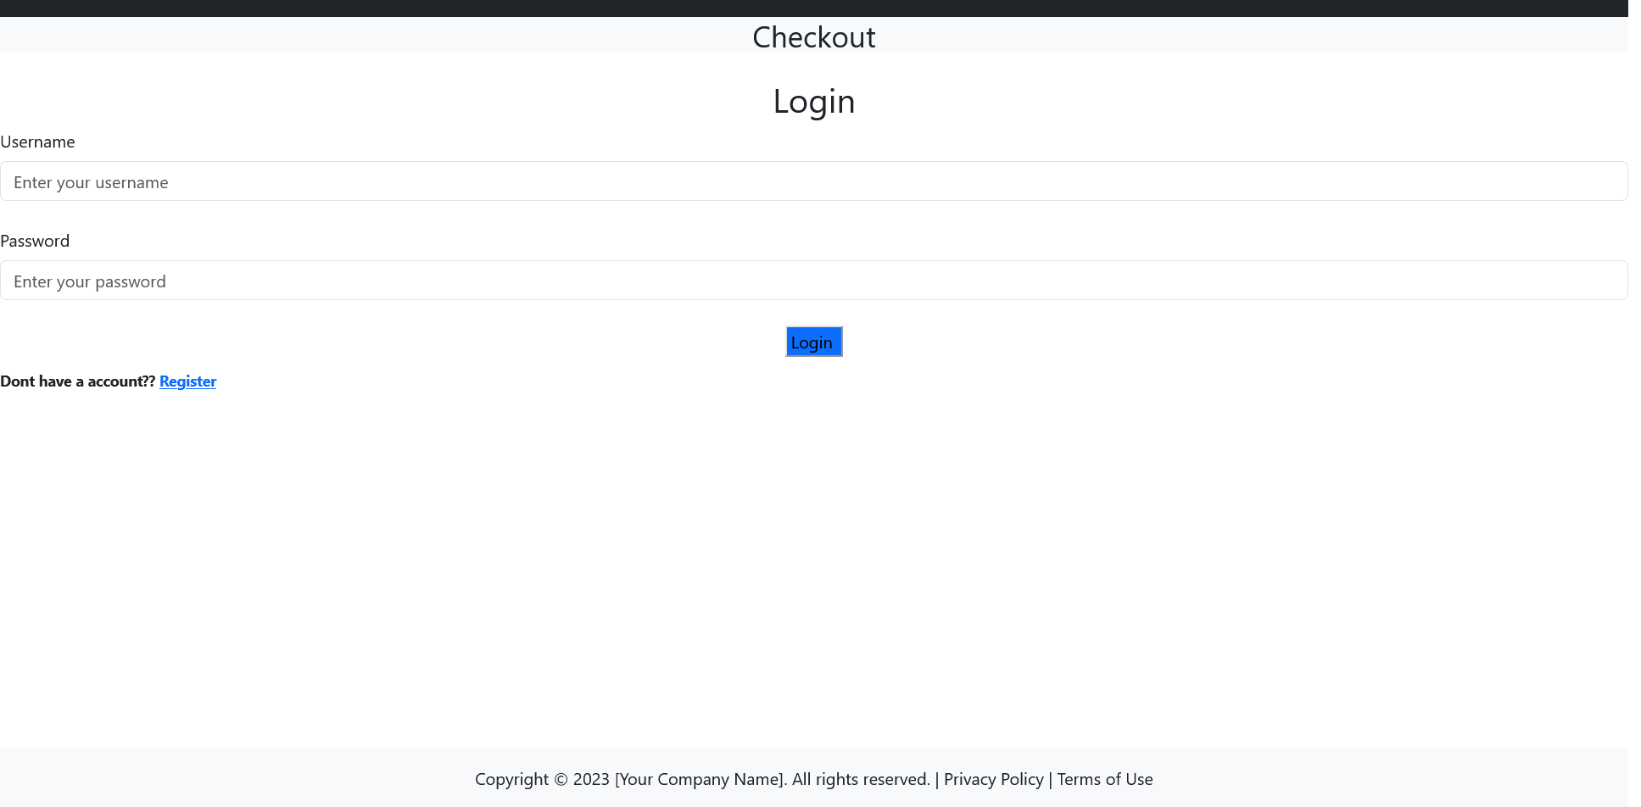

**Register Page:**

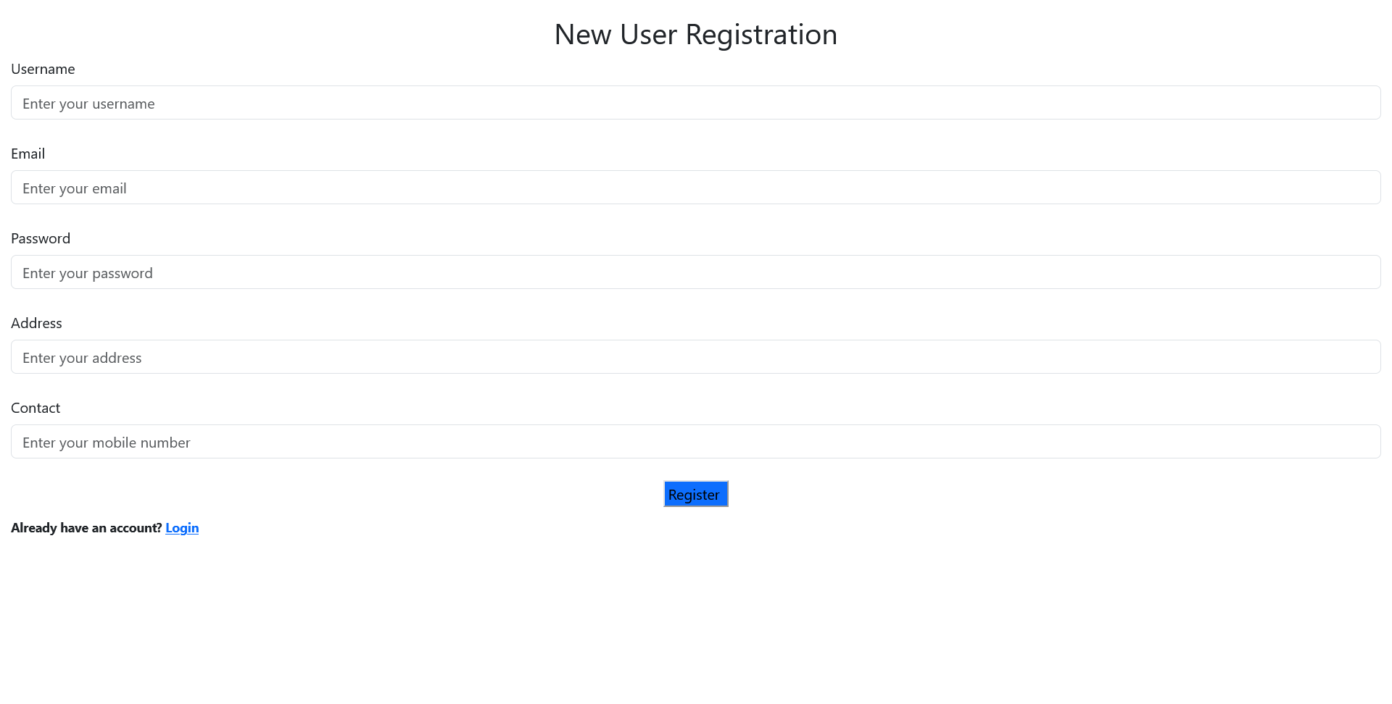

**Payment Page:**

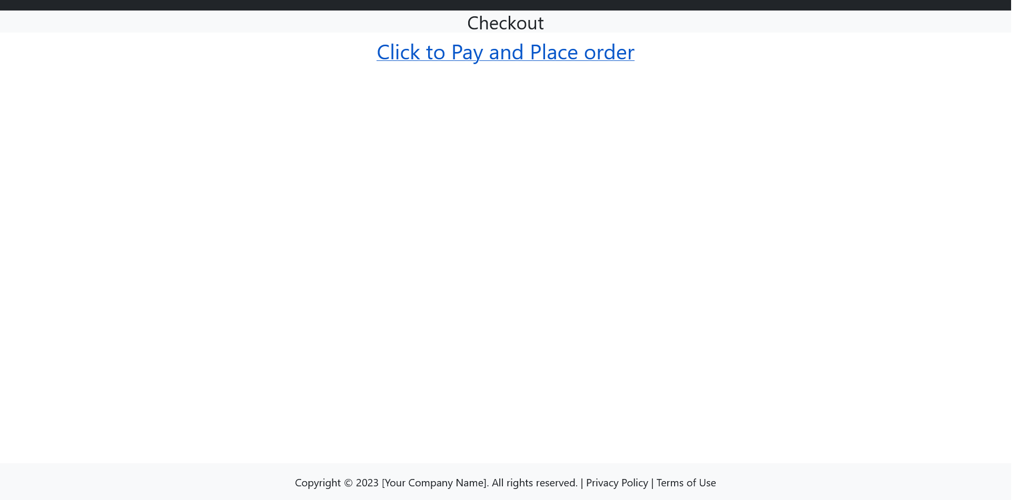

**Order History on User Panel:**

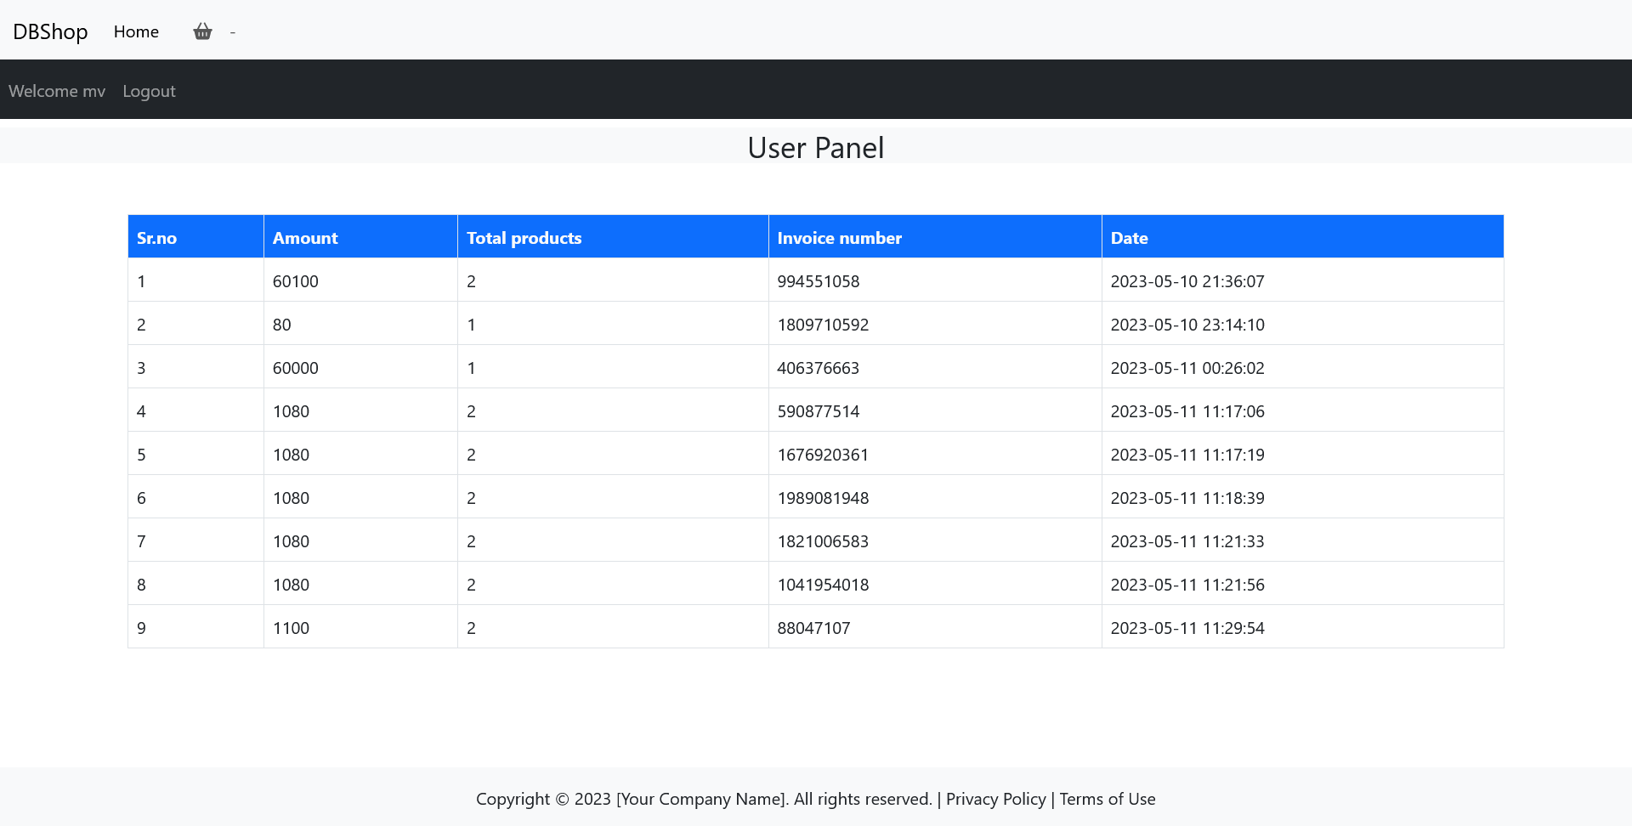

**Admin Panel Default View:**

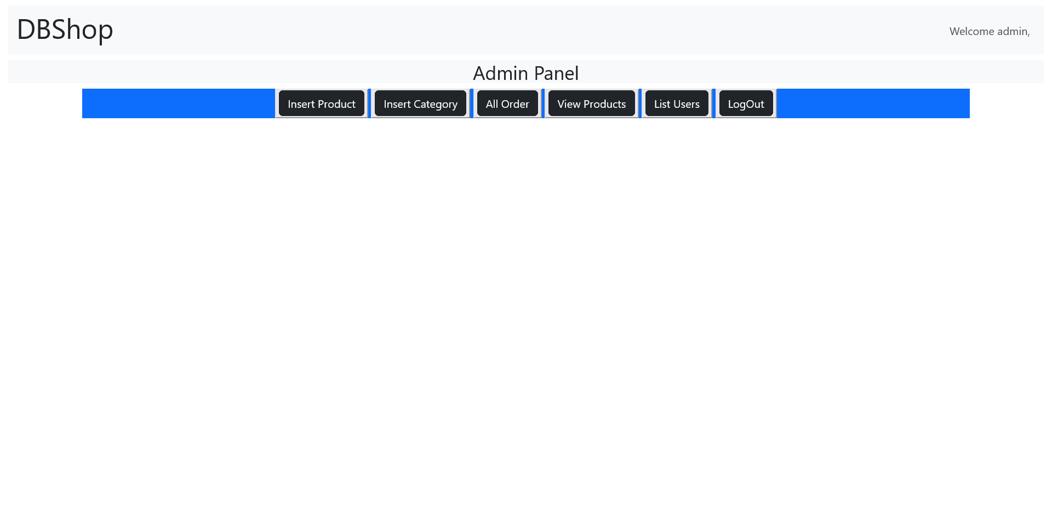

**Admin Panel Default View:**

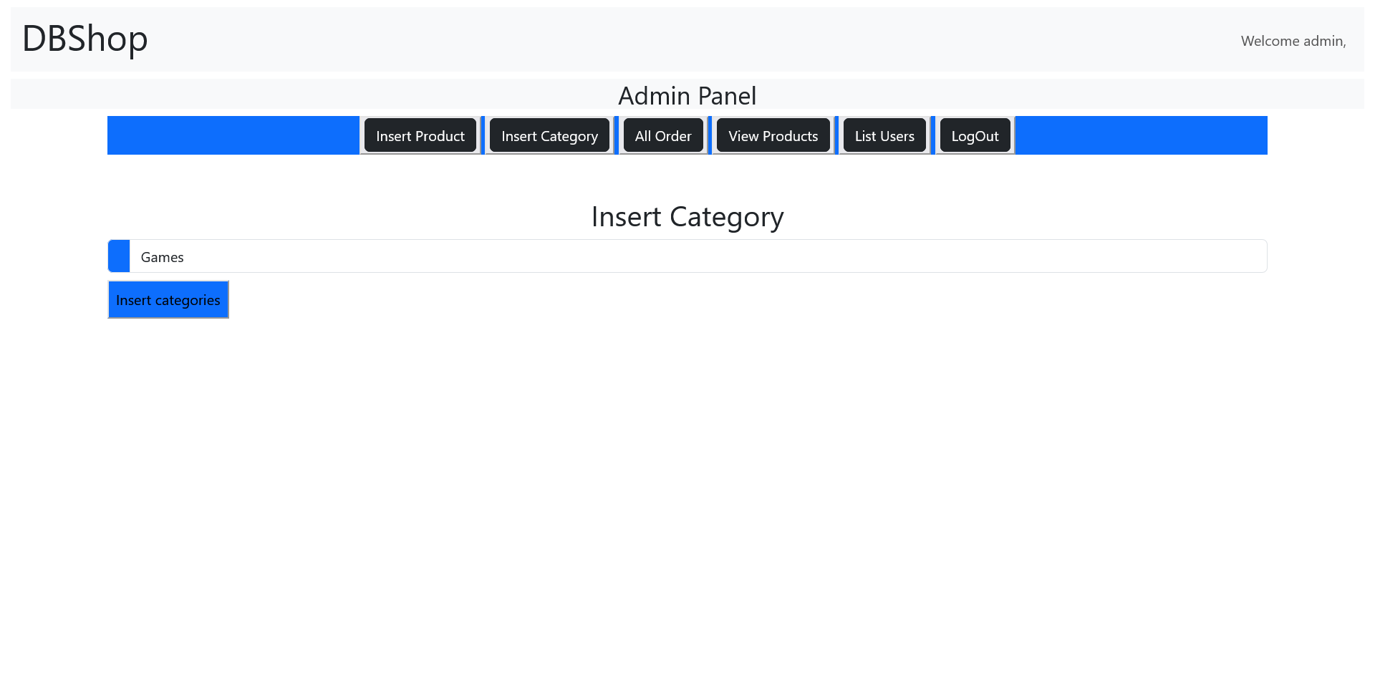

**Admin Panel Insert Products View:**

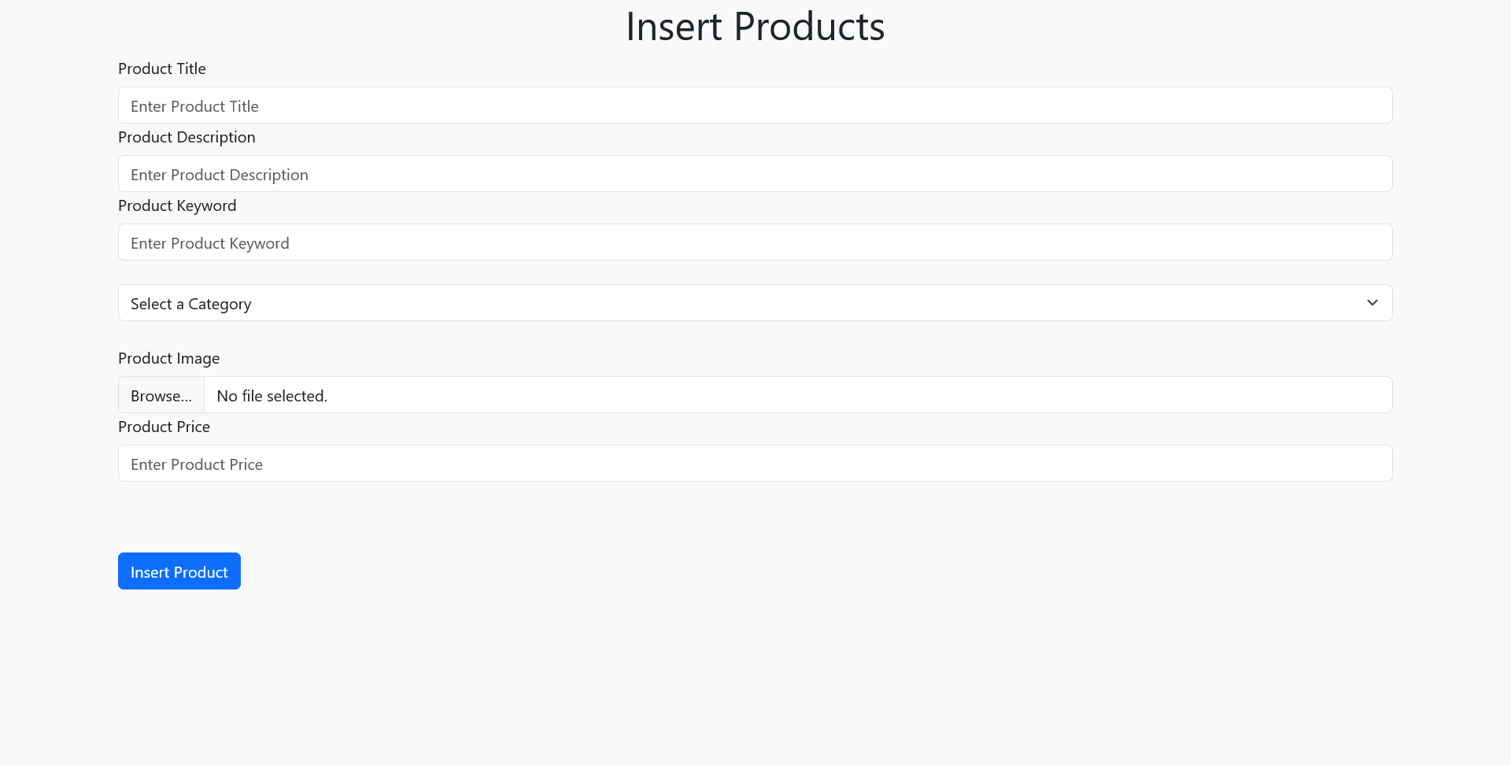

**Admin Panel View Products:**

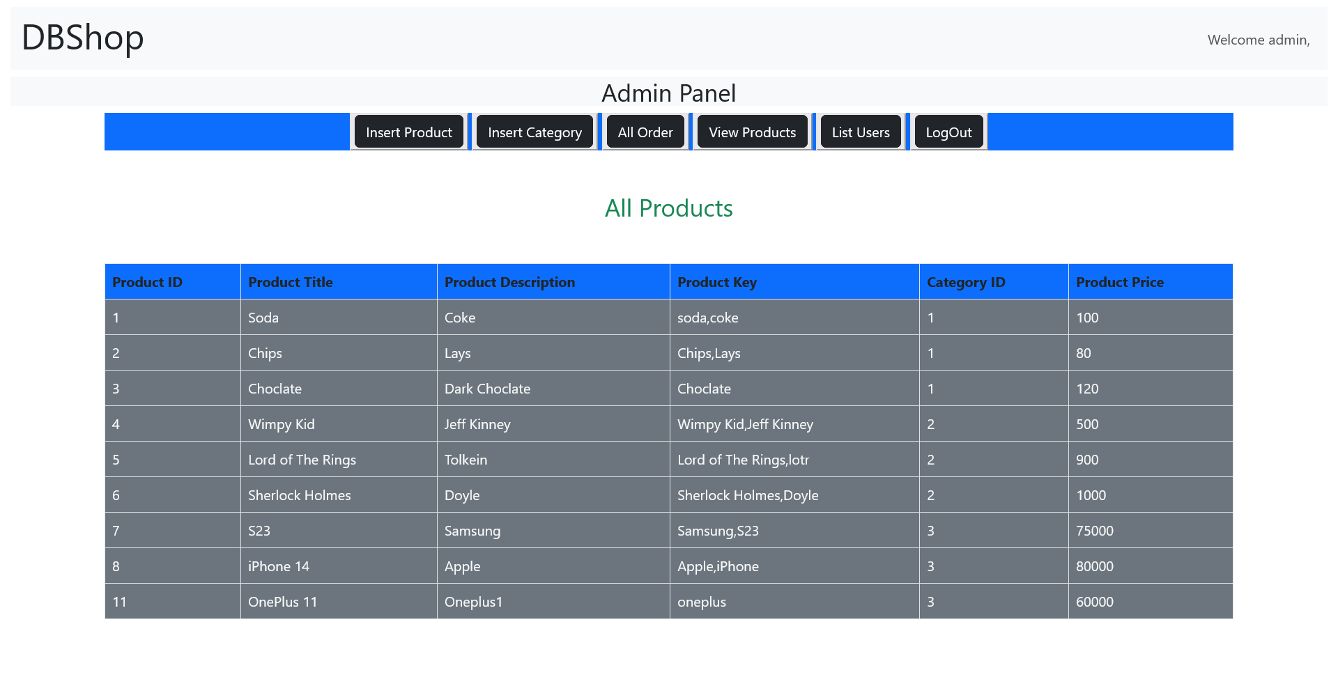

**Admin Panel View Products:**

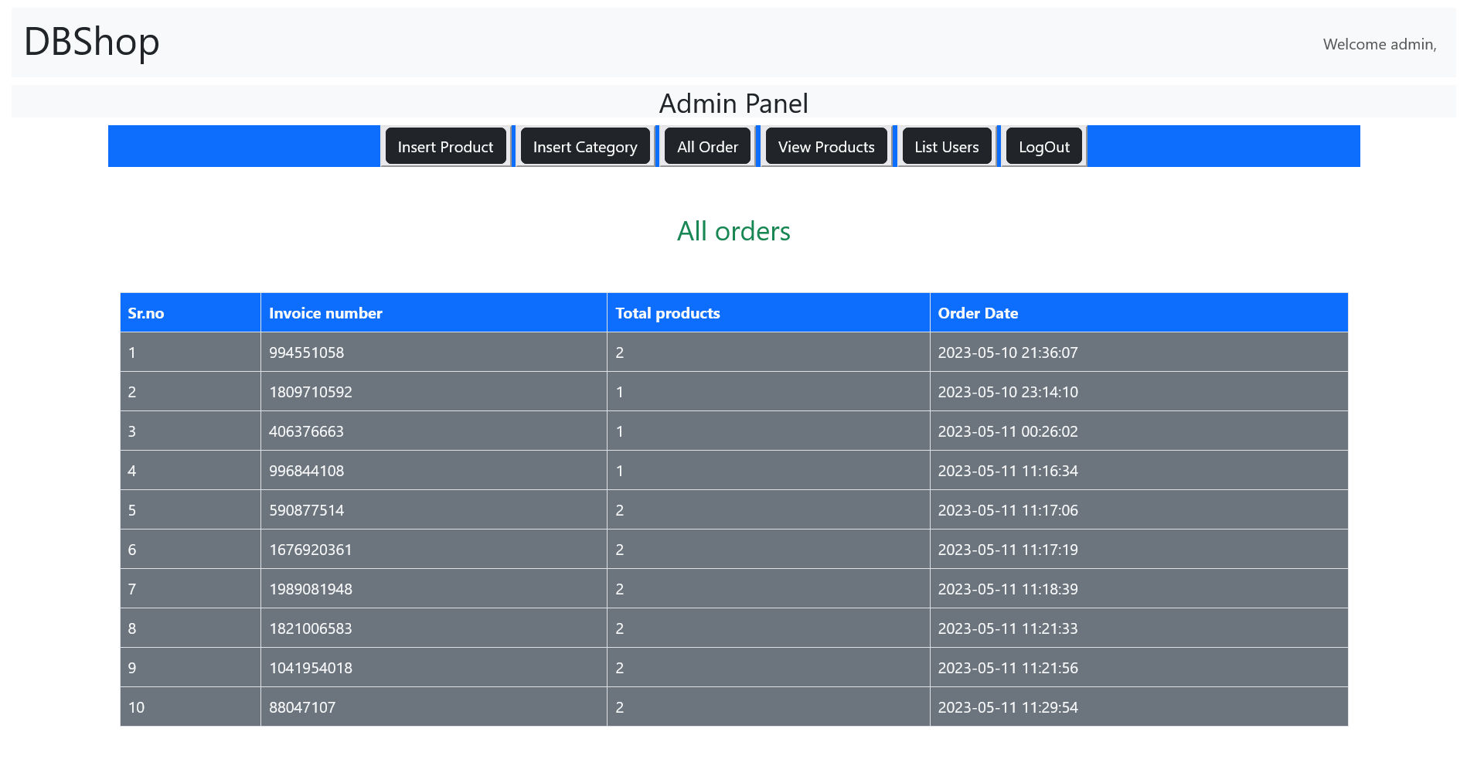

**Admin Panel View Users View:**

